Team ID : **PNT2022TMID47056**

Project : Smart Fashion Recommender Application

Team member 1

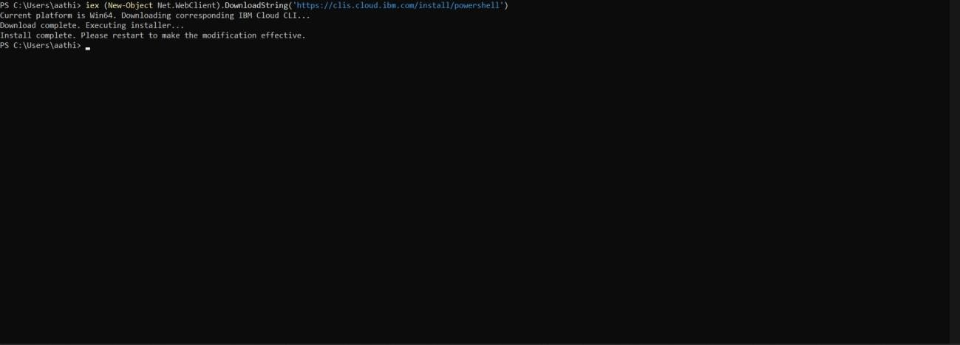

Team member 2



Team member 3

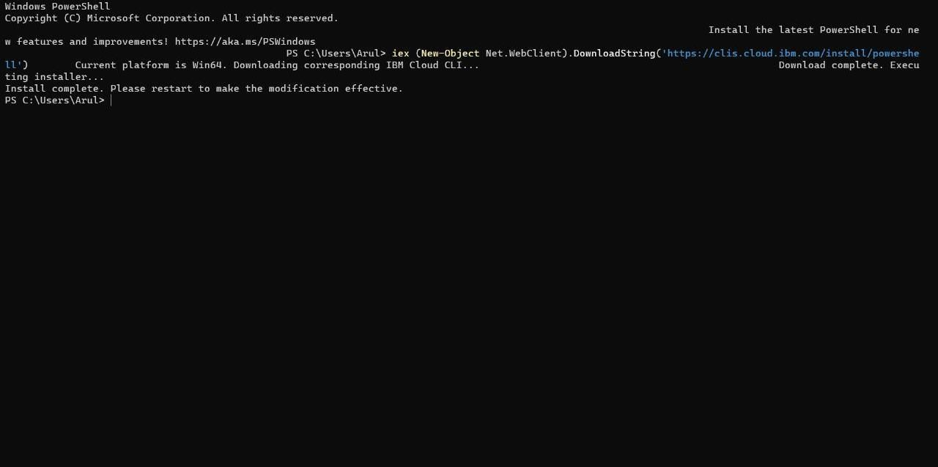

Team member 4

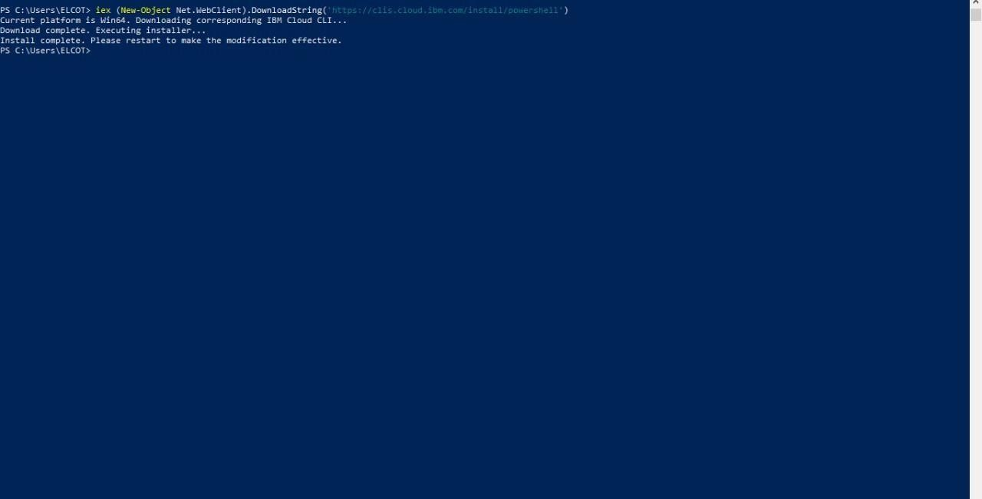

Team member 5

